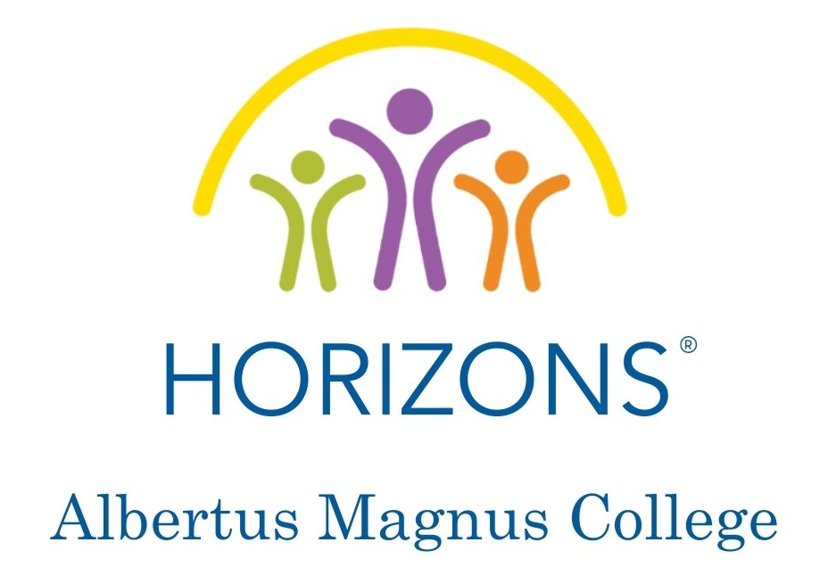

FAMILY HANDBOOK
2021

700 Prospect Street
New Haven, CT 06511

(203) 807 – 5471
horizonsatalbertus@gmail.com

Site Director: Stephanie Kadam
Assistant Site Director: Brenda Moreno
WELCOME TO HORIZONS AT ALBERTUS MAGNUS!

I am excited to welcome your family to the first summer of Horizons at Albertus Magnus! The staff has been working hard to prepare a great experience for the students this summer and we can’t wait to meet you all!

The past year and a half has been tough for many families, especially the children. I know that the in-person Horizons experience is something that none of us will take for granted.
Still, we all need to work as one to keep the students safe, healthy and engaged for our four weeks together.

This handbook will help you understand how we plan for the health and safety of your child when he or she is at Horizons and some things that you can do to make sure your child has a successful experience. Also note that we are monitoring the COVID-19 pandemic and current CDC guidelines, and will communicate any updates to our procedures as needed.

If you have any questions about this handbook please contact me.

Warmly,
Stephanie Kadam
stephanie.kadam@gmail.com

CAREGIVER’S ROLE

The following are things that we recommend you do to help your child have a successful experience at Horizons:

- Take precautions against the COVID-19 pandemic.
  - Make sure your child wears a mask in public.
  - Limit outside contact and exposure to anyone and remain 3 – 6 feet from others in public.
  - Limit travel during the four-week program.
- Bring your child to Horizons every day! Drop them off and pick them up on time.
- Ensure your child is prepared to take part in all activities by dressing in appropriate clothes and shoes.
- Review the behavior expectations with your child. Remind your child how important it is to follow directions.
- Communicate with the staff! Let us know if something is happening in your child’s life that could affect his or her behavior or mood. Also, be available to speak with our staff if requested.
- Take a little time each day to ask your child what they are doing at Horizons.

Together we can provide a very special experience for your child.
We look forward to a GREAT summer and many more to come!

COMMUNICATION

We hope that you will actively participate in your child’s Horizons experience and encourage open lines of communication between parents and Horizons teachers and staff. We urge you to openly discuss ideas and concerns with us.

Horizons communicates with families in the following ways:

Phone
(203) 807 – 5471
Expect your child’s teachers to call you regularly to check in about your child’s progress and experience at Horizons and ask for your feedback. Feel free to contact them to check in or with questions or concerns. Teachers will return non-urgent phone calls at the end of each day.

Email
Group communications to the families will primarily be done through email. Please let us know if there are additional email addresses that should be receiving communications.

Individual Meetings
Feel free to contact your child’s teacher to set up an individual meeting to discuss any concerns or check on your child’s progress.

Horizons Meal Calendar
Families will receive this by email each month of the program.

Let us know if your contact information changes!
We want you to stay informed. It is very important that you notify Horizons at Albertus Magnus College of any address, email, or telephone number changes immediately.

PROGRAM INFORMATION

Summer Program
The summer program runs from July 19 – August 13, 2021. The day begins promptly at 8:30 am and ends at 2:50 pm, Monday through Friday. This year the program will be comprised of four classes: Kindergarten through Grade 3. As the children move up to a new class each year, we will add a new class of Kindergartners.

At Horizons, your child will take part in academic enrichment classes in literacy and math, have plenty of outdoor time, eat nourishing breakfasts, lunches, and snacks, go off campus for culturally enriching field trips, and participate in specials such as STEM, art, and sports. They will make new friends and create special bonds with their teachers and members of the Horizons community.

Admission / Re-Enrollment
Each year, Horizons receives many more applications than we have spaces. As an enrolled Horizons student your child will receive a space in the program for the next summer if (1) they have met the attendance and tardiness requirements below for the current summer; (2) the re-enrollment form and fee are submitted by the due date; and (3) we have received your child’s medical evaluation. The re-enrollment form is online and will need to be completed each year.

Attendance
Horizons is a full scholarship program. Your child’s attendance is considered your payment for the program. It is the parent’s responsibility to get the child to the program on time each day.

Poor attendance and repeated tardiness are important determining factors in admission for future years at Horizons. If your child is too ill to attend, call Horizons at (203) 807 – 5471 by 8:30 am. A doctor’s note may be required for the absence to be excused.

Arrival and Departure Policy
The program begins at 8:30 am and ends at 2:50 pm Monday through Friday.

All families will drop off and pick up their children at Albertus Magnus College in front of the Tagliatela Academic Center. Plan to arrive promptly at 8:10 am at the designated drop-off point on campus and promptly at 2:50 pm for pickup.

Only designated adults will be allowed to pick up the students at the end of the day. Staff will check the adult’s photo identification before releasing the student to them.

Temperature Check
As part of our arrival routine, a staff member will be checking the temperature of the students. Students with a temperature of higher than 100ºF will not be allowed to participate in the program that day.

Program Location
Albertus Magnus College, New Haven CT
- Tagliatela Academic Center
- Aquinas Hall

Food Policy
Horizons will serve each student a healthy breakfast, lunch and snack each day. No nuts will be used in the food prepared. Hydration is important, so we also will provide water and/or juice. Please do not send your child to the program with any food or beverages.

Meals
All meals and snacks are provided and will be eaten outdoors or in the classroom while socially distancing. This year we are partnering with New Haven Public Schools to manage our food services.

Clothing Policy
Horizons students need to come prepared for active and fun-filled days. All students should have:

- Athletic shoes that can be worn for sports (no flip flops)
- Shorts and tee-shirts (no belly shorts or bare midriffs)

Masks
Masks are required by all staff and students while indoors. Outdoors, students may take their masks off, but are required to maintain social distancing of at least 6 ft. Mask breaks will be given periodically throughout the day and at meals.

Classrooms
All students will be socially distanced at 3ft inside the classroom.

Internet and Technology
Students will have the opportunity to use computers in the Computer Lab and/or Chromebooks. As with all computing resources, Albertus Magnus College’s connection to the internet is provided for professional and academic work. Any work done on these computers or devices connected to the college’s network can be monitored directly or remotely at any time. Any work done on the internet that might offend or upset others in the community is prohibited. Network activity of students is subject to adult supervision and monitoring. Technology protection measures may be disabled for adults or, in the case of students, minimized only for bona fide research or other lawful purposes.

Discipline Policy
The Horizons program offers a nurturing environment built on respect for members of the community. We provide a structure of loving discipline, limits and standards of behavior are essential to the development of each child’s positive self-image. Horizons makes the final decisions about all discipline issues. Consequences may range from discussions about behavior to expulsion. In all cases, parents or guardians are asked to be involved in the process.

Citizenship
All children are expected to behave politely, to respect the college’s property, and take an active role in their own learning. Students at Horizons at Albertus Magnus College’s will discover what it means to be a “GREAT” member of the community. They will practice being good citizens with their teachers and fellow students and we hope that you will help us reinforce these attributes at home.

These words remind Horizon’s students how to be GREAT members of our community:

G growth
R respect
E enthusiasm
A adventure
T together

Health
All students must have the required medical form fully completed and on file in order to begin the program. Horizons will have an on-call nurse and onsite staff who are certified in CPR and First Aid Monday – Friday.

Please keep Horizons informed of changes in work and emergency phone numbers. In an emergency, a reasonable effort will be made to contact the parent/guardian/emergency contact. Should this fail, the student will be taken to the nearest physician or hospital for treatment. If a child becomes ill during the session, the parent or guardian will be notified and will be asked to pick the child up early. In such a case the child will remain out of the classroom until his or her parent, guardian or emergency contact arrives. If the injury is minor (i.e. small scratches, bruises, insect sting without allergies) the parent or guardian will be contacted at the end of the day.

Medication and Extra Clothing
Medication needs to be in its original packaging with the pharmacy label on the box or container and the child’s name should be clearly visible. If you feel that your child might need extra clothing, it should be in a plastic bag clearly labeled with your child’s name. Medication and extra clothes will be kept in the Director’s Office and returned at the end of the program.

Health Policies
If your child has a fever or symptoms, please keep him or her home until he or she is fever-free for 24 hours without the use of fever-reducing medication or have a signed doctor’s note before they can return to Horizons. If your child has vomited in the morning, please do not send him or her to the program that day. Please call us to report your child’s absence at (203) 807 – 5471.

Fire Procedures
A fire drill will be held during the first week of the program each summer to prepare the children for the proper response to a fire alarm. Emergency evacuation routes are posted by all classroom doors. During a fire drill, Horizons staff members will follow the established policy to evacuate the building. Once evacuation has occurred, no child or staff will be permitted to re-enter any building until the fire alarm has been turned off and school officials signal that it is safe to enter.

Plumbing Failure, Bomb Threats, Shelter in Place, Natural Disaster Procedures
During any of these incidents, Horizons teachers and staff will follow established procedures to ensure the safety of all children. If a building must be evacuated, students and staff will assemble in their designated fire-drill areas and attendance will be taken. Parents will be notified in the unlikely event of an incident that requires evacuation.

