02/12/2024
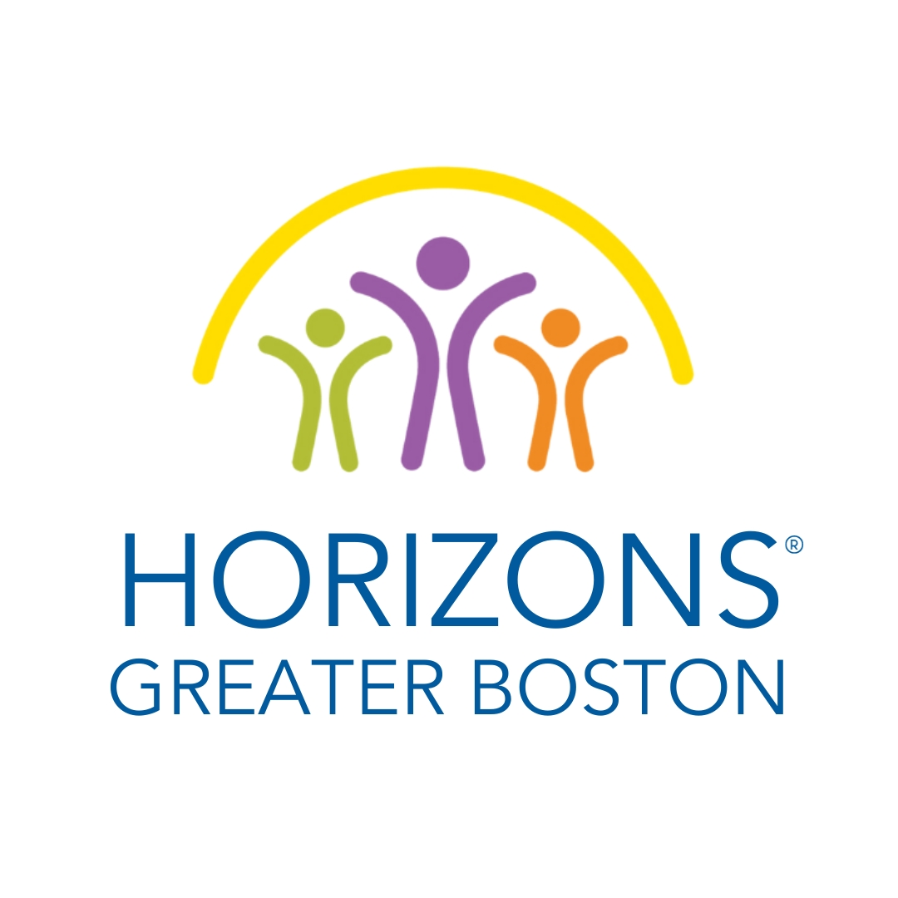

Position Title: Executive Director, Horizons Greater Boston
Direct Supervisor: Board President
Employment Type: Full-Time Exempt Salary Range: $100,000 - $120,000
Location: Remote and in-person at local Horizons sites Position Start Date: Spring 2024
About Us

Horizons Greater Boston is a community-centered education program serving students from the Greater Boston Metro area. We advance educational equity by building long-term partnerships with students, families, communities, and schools to create experiences that inspire the joy of learning.
Horizons Greater Boston (HGB) was founded in 2019 to expand Horizons programming in the Boston area and to support existing area sites, which included Horizons at Dedham Country Day School and Horizons at Lexington Montessori School. Horizons partners with these independent schools, to serve students that have been marginalized and who attend public schools in the Greater Boston area. HGB launched Horizons at Mattahunt Elementary School in 2019. Horizons Greater Boston is an affiliate of Horizons National, which has over 70 programs in 20 states nationwide.
Currently serving approximately 400 students with a goal of expanding to build capacity to serve 700 students by 2026, Horizons Greater Boston is continuing to build upon the strong community of support in the Greater Boston area within our three existing local sites. We are committed to building new partnerships with all types of educational institutions – public, private, and charter schools, colleges, and universities – to launch thriving and sustainable community-based Horizons programs across Greater Boston and provide more opportunities for students to learn, grow, and achieve their goals.
To learn more about Horizons Greater Boston, please visit Horizons Greater Boston
About the Position

This is an exciting leadership opportunity for a seasoned, dynamic nonprofit professional who is passionate about building the capacity of students, families, and communities and creating opportunities for students to develop the academic and social emotional skills that will enable them to thrive. The Executive Director will lead all operations of Horizons Greater Boston, including fundraising and communications, building a regional staffing structure, supporting Boston-area site-level Horizons Executive Directors, managing financial operations, reporting, and supporting the regional board of directors to ensure the quality and impact of all Horizons programming in Greater Boston. This role also serves as the face of HGB, working to build external-facing relationships to increase awareness of the program, expand partnerships, and position Horizons as a thought leader in the out-of-school time space. The Executive Director will work in partnership with the 12-member HGB Board of Directors as well as Horizons National and the local host educational institutions to cultivate and launch new Horizons programs across Greater Boston. The successful candidate will bring a passion for the mission of closing the opportunity gap in education.
As part of a national network, HGB’s Executive Director has access to professional development opportunities, peer-to-peer learning and collaboration, and programmatic and strategic guidance from Horizons National, the hub of the Horizons Network.

Key Responsibilities

Fundraising and Communications
- Collaborate with the HGB Board on fundraising strategy, including cultivation of new funding sources
- Build and maintain strong relationships with funders; write grant requests and prepare all required grant reporting
- Plan and oversee cultivation events, including summer site visits
- Coordinate all public relations and communications activities, including social media and community outreach, using branded Horizons resources
- Work in close collaboration with existing Greater Boston Horizons sites to coordinate fundraising efforts
Organizational Leadership
- Provide leadership and tactical implementation for organizational strategy, fundraising, financial management, programmatic growth and quality, infrastructure, and board development for an expanding non-profit
- Manage with assistance from the external accounting firm, the overall budgeting, financial planning, and financial reporting, including the preparation of the annual financial review and Form 990
- Partner with the HGB Board, providing leadership and support to members and committees, including the development of meeting materials and presentations
- Execute formal agreements and serve as a liaison between HGB, program host institutions, and Horizons National
- Represent HGB at relevant field events, including the annual Horizons National Conference and Boston-area educational and non-profit events

Program Leadership
- Work with the HGB Board and Horizons National to identify and cultivate institutional partners and launch new programs at schools and/or other institutions
- Create and maintain a supportive regional Horizons community
- Work with host schools and site boards to provide annual feedback for site directors and program operations
Skills and Qualifications

- Experience leading fundraising activities, including donor relations and events
- Excellent written and verbal communication and presentation skills
- Strong project management and organizational skills, attention to detail, and ability to set and meet deadlines with competing priorities
- Strong interpersonal skills and demonstrated ability to build and sustain positive and respectful relationships, with a sense of cultural competency and experience working with a diverse range of stakeholders
- Familiarity with program administration, including operations and staff management
- Experience with financial reporting, grant administration, and budgeting
- At least ten years of prior experience, including demonstrated success in leadership roles in a nonprofit setting (preferably working with youth), along with a bachelor’s degree or higher

Our Commitment to Equity, Diversity, and Inclusion

HGB strives to create an inclusive, affirming, and welcoming environment that allows all team members to thrive. As an organization whose central purpose is to mitigate inequities in education, Horizons is strongly committed to Equity, Diversity, and Inclusion (EDI) in all forms, and we strongly denounce racism, sexism, and discrimination of any kind. Focus on EDI is central to Horizons National and our National Network, which actively engages in diverse and inclusive partnerships, representative councils, and working groups; provides robust professional development opportunities; evaluates internal and external communications with an asset-based lens; and facilitates conversations across different communities to ensure that all Horizons voices are heard and represented. Because of our Network-wide commitment to EDI, the ideal candidate for this role must be comfortable engaging in discussions, self-reflective, and willing to challenge themselves and others to learn and grow continuously.
HGB does not and shall not discriminate based on race, color, religion (creed), gender, gender expression, age, national origin (ancestry), disability, marital status, sexual orientation, or military status in any of its activities or operations. These activities include but are not limited to hiring and firing staff, selection of volunteers and vendors, and provision of services. We are committed to providing an inclusive and welcoming environment for all members of our staff, parents, and children in our programs, volunteers, subcontractors, and vendors.
Employment opportunities shall be provided for applicants with disabilities, and reasonable accommodation(s) shall be made to meet the physical or mental limitations of qualified applicants or employees.
Compensation and Benefits:
The salary range for this full-time position is $100,000-$120,000, commensurate with experience, plus benefits. The HGB Executive Director can work remotely from within the Greater Boston area and/or from one of the sites. During the summer months, significant on-site work at HGB sites is required. Some local travel is to be expected throughout the year, as well. Horizons Greater Boston is a 501(c)(3) organization and an affiliate of the Horizons National network.
Application Process:
Interested candidates should submit an employment application to hr@horizonsgreaterboston.org. Please submit a thoughtful cover letter and a resume outlining how your skills and experience meet the qualifications of this position. Interviews will be scheduled on a rolling basis and may include phone, virtual, or in-person interviews.

